**Lab 5P: Repetition Structures_ 5P_RSX**

**GADDIS Text Pages 199 - 201**

**Using the IDLE editor (FILE/New Window)……**

**Name: ____________Jeff Couch_____________**

**EXTRA CREDIT (205 Pts)**

**For EACH EXTRA CREDIT Project you complete:**

**Take one Screenshot of both the EDIT window disiplaying your program and**

**the SHELL window displaying your program results and paste where indicated.**

**SAVE your program. All extra credit programs must be submitted with this lab template**

**Project 2. Calories Burned (25 Pts)**

**Input: Minutes = 10,15,20,25,30**

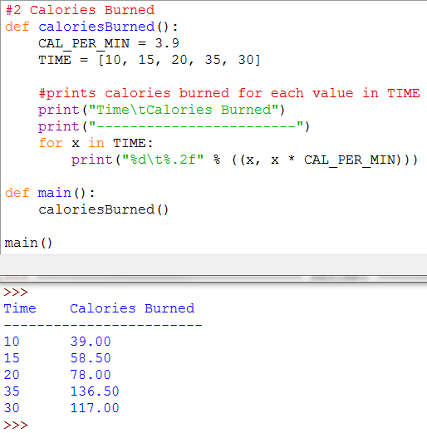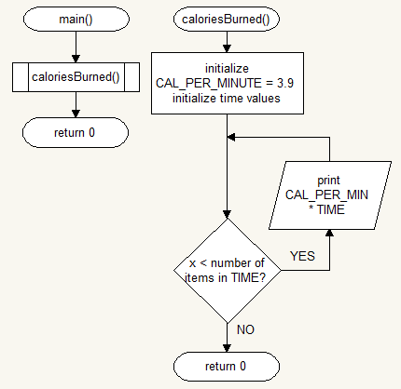

**Project 3: Budget Analysis (25 Pts)**

**Input: Budget($) = 2500**

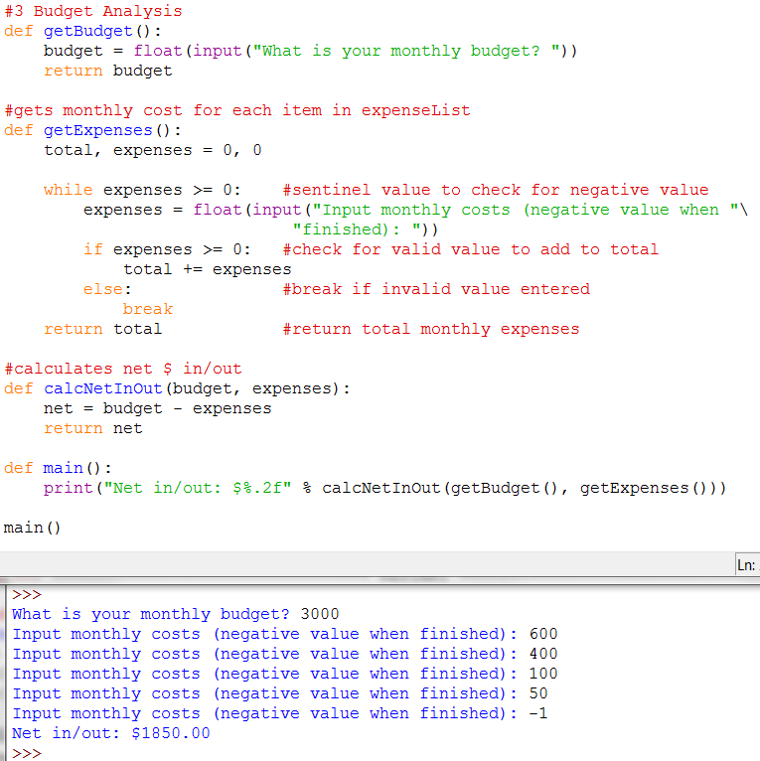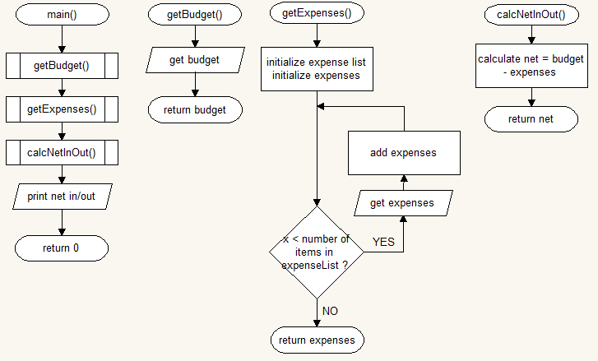

**Project 4: Distance Traveled (25 Pts)**

**Input: Speed(mph) = 75, Time(hrs) = 4.5**

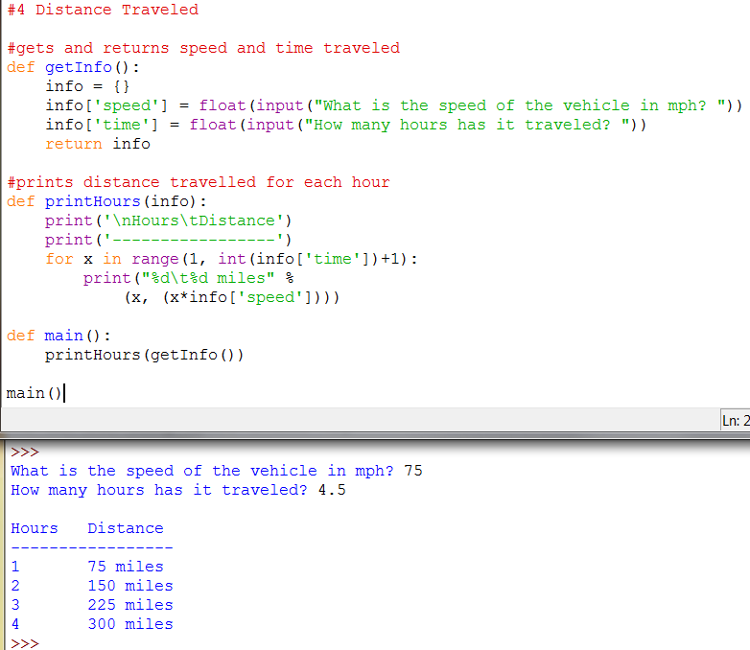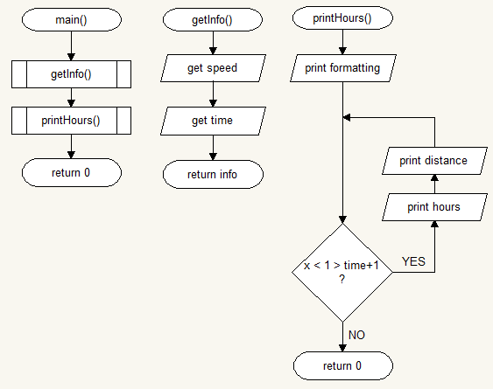

**Project 6: Celsius to Fahrenheit Table (25 Pts)**

**Input: Temps(C) = 0,1,2,3,4,5,6,7,8,9,10,11,12,13,14,15,16,17,18,19,20**

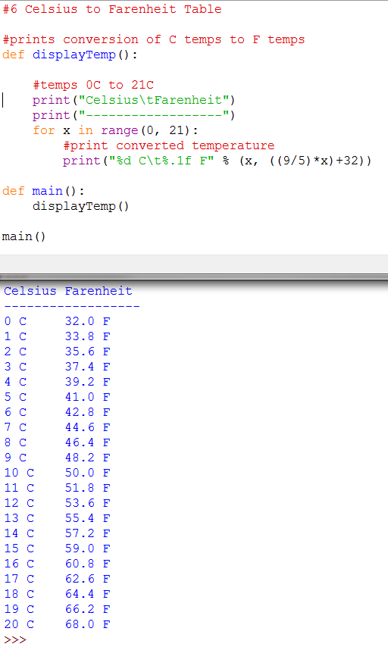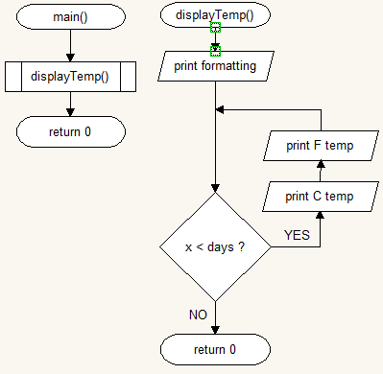

**Project 7: Pennies for Pay (25 Pts)**

**Input: Number of days = 720**

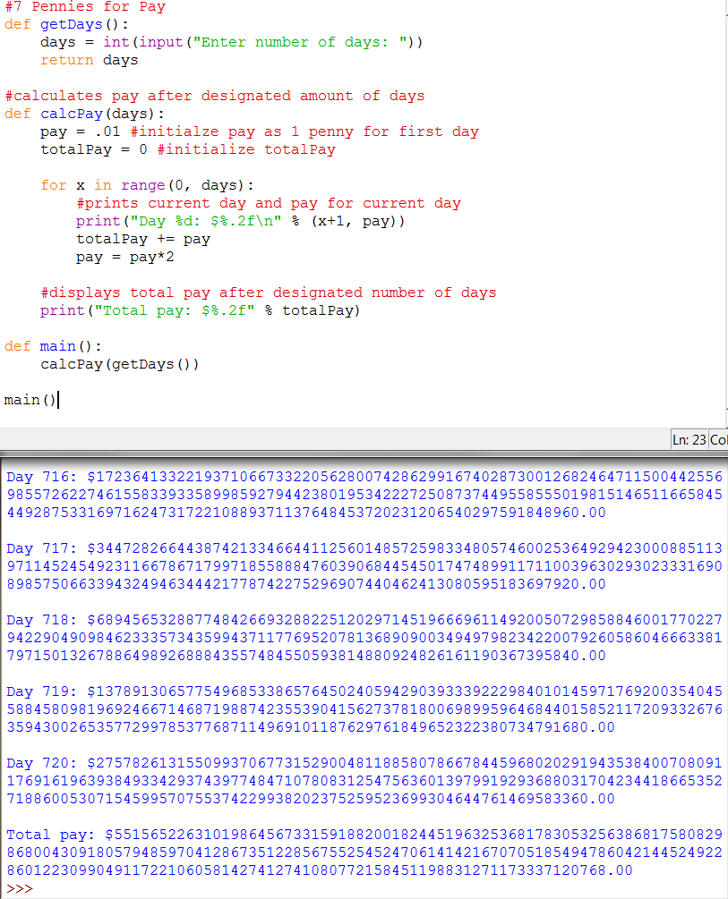

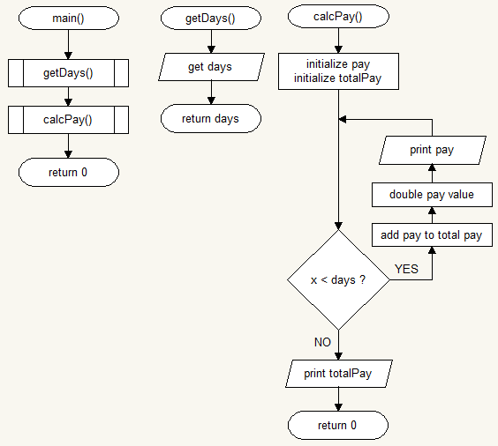

**Project 9: Write a program that uses nested loops to draw this pattern: (35 Pts)**

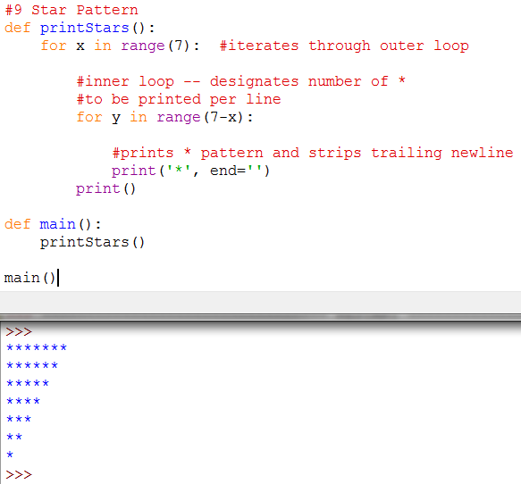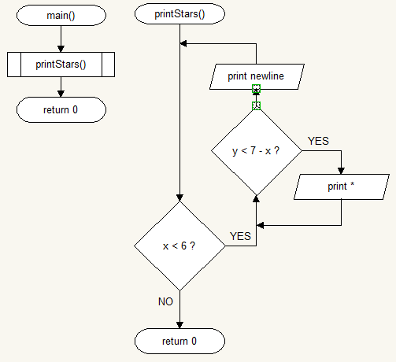

**Project 10: Write a program that uses nested loops to draw this pattern: (45 Pts)**

